29th April 2019

**WTCR in Hungary brings the Argentinians on Top**

The WTCR – FIA World Touring Car Cup which boasts the Japanese premium tyre manufacturer YOKOHAMA as exclusive Tyre supplier delivered a weekend of hugely close and action-packed racing as Honda-powered Néstor Girolami took a double win to move into the lead of the series.

While there was joy for Argentina, the thousands of Hungarian fans cheering local hero Norbert Michelisz had to make do with second place following Gabriele Tarquini’s Race 3 victory at the expense of his BRC Hyundai N Squadra Corse team-mate.

As in 2018, Michelisz started on Pole Position but was unable to keep Tarquini – the inaugural WTCR / OSCARO title winner – at bay. The Italian veteran and current Champion is once again a strong contender for overall glory.

After finishing third in Race 1 to take the title lead, Esteban Guerrieri was fifth in Race 2 before dropping out of the Race 3 lead when an electrical issue triggered a momentary power loss. It would get worse for the ALL-INKL.COM Münnich Motorsport driver when he crashed into retirement later on with broken steering, the legacy of damage sustained in Race 2.

Yvan Muller achieved his first podium of 2019 with second in Race 1, while his nephew and fellow Lynk & Co-powered racer Yann Ehrlacher took third in Race 3, which, like Race 2, took place on a damp track.

Jean-Karl Vernay started the reverse-grid Race 2 from Pole Position but a clutch problem led to a sluggish start. He finished second ahead of Hungaroring rookie Daniel Haglöf, the Swede claiming the new PWR Racing’s second podium of the season, one place ahead of CUPRA-driving team-mate Mikel Azcona, who also took fourth in Race 3.

Aurélien Panis was fifth in Race 1 for Comtoyou DHL Team CUPRA Racing. Thed Björk, who arrived in Hungary leading the standings, came away with a weekend-best fifth in Race 3 and now drops to 3 in the Driver standings.

The next race weekend will be held in Slovakia 10th-12th May.

Driver Standings:

1 Néstor Girolami 100

2 Esteban Guerrieri 90

3 Thed Björk 81

4 Gabriele Tarquini 79

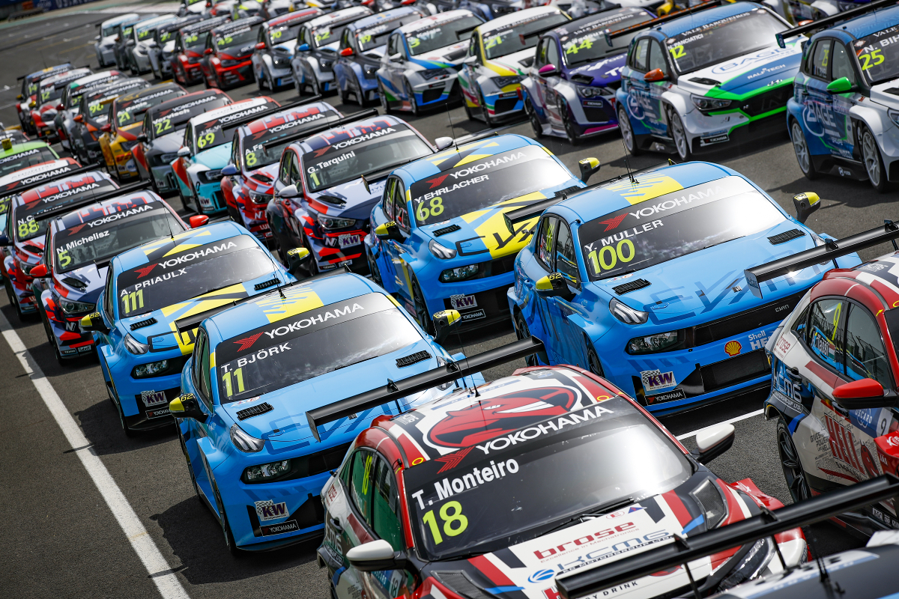

*The WTCR and TCR Europe family picture during the Race of Hungary Photo by Floren Gooden DPPI*

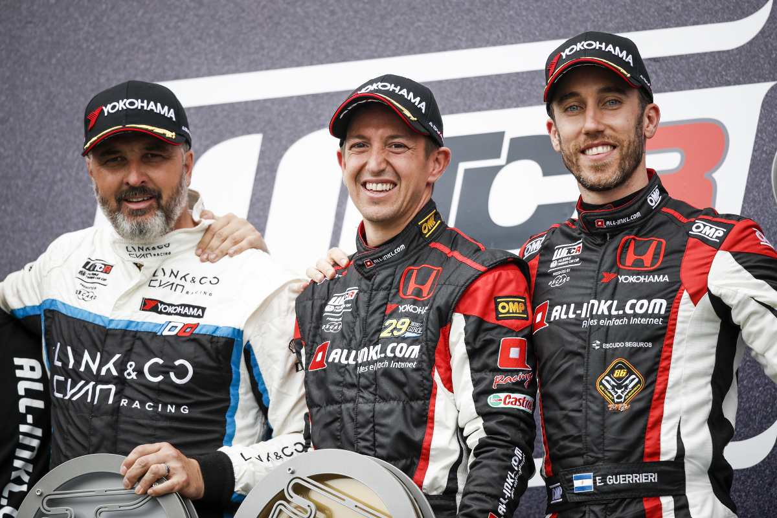

*Left to Right Yvan Muller Nestor Girolami and Esteban Guerreri at the WTCR Race of Hungary Podium*